Vodafone Gigabox

User's Guide

Table of Contents
Chapter 1 Introduction 1
Features 1
Package Contents 2
Physical Details 3
Chapter 2 Installation 6
Requirements 6
Procedure 6
Chapter 3 Setup & Status Basic Mode 9
Overview 9
Configuration Program 9
Overview Screen 10
Phone - Call Log 11
Internet - Firewall 12
Wi-Fi - General 13
Wi-Fi - Schedule 15
Wi-Fi - WPS 16
Sharing - General Setting 18
Settings - Password 19
Settings - Configuration 20
Settings - Energy Settings 22
Status & Support - General Information 24
Status & Support - Diagnostic Utility 29
Status & Support - Reset Connections 31
Status & Support - About 32
Chapter 5 Troubleshooting 33
Overview 33
Problems 33
Appendix A Specifications 34
Vodafone Gigabox 34
Regulatory Approvals 34

P/N:
Copyright © 2018. All Rights Reserved.
Document Version: 1.0
All trademarks and trade names are the properties of their respective owners.

Chapter 1
Introduction
1
This Chapter provides an overview of the gateway's features and capabilities.
Congratulations on the purchase of your new Vodafone Gigabox. The Vodafone Gigabox is a multi-function device that provides the following functions:
- Four Gigabit Ethernet Ports
- Two Telephony Ports
- One DSL Port
- One Gigabit WAN Port
- Wi-Fi
- One USB Port

Features
This gateway is a data communication device that incorporates many advanced features, carefully designed to provide sophisticated functions while being easy to use.
This device also offers the functions of telephone devices for voice over IP calls. You can attach two tethered analogue end devices such as telephone, answering machines or fax devices.

Internet Access Features
- Shared Internet Access. All users on the LAN or WLAN can access the Internet through the device, using only a single external IP Address. The local (invalid) IP
Addresses are hidden from external sources. This process is called NAT (Network Address Translation).
- PPPoE, Direct Connection Support. The device supports all common connection methods.
- Fixed or Dynamic IP Address. On the Internet connection, the Vodafone Gigabox supports both Dynamic IP Address (IP Address is allocated on connection) and Fixed IP Address.

Advanced Internet Functions
- Special Internet Applications. Applications which use non-standard connections or port numbers are normally blocked by the Firewall. The ability to define and allow such applications is provided, to enable such applications to be used normally.

LAN Features
- 4-Port Switching Hub. The device incorporates a 4-port 10/100/1000BaseTswitching hub, making it easy to create or extend your LAN.
- DHCP Server Support. Dynamic Host Configuration Protocol provides a dynamic IP address to PCs and other devices upon request. The device can act as a DHCP Server for devices on your local LAN and WLAN.

Configuration & Management
- Easy Setup. Use your WEB browser from anywhere on the LAN or WLAN for configuration.
- Configuration File Upload/Download. Save (download) the configuration data from the Vodafone Gigabox to your PC, and restore (upload) a previously-saved configuration file
- UPnP Support. UPnP (Universal Plug and Play) allows automatic discovery and configuration of the Vodafone Gigabox. UPnP is supported by Windows ME, XP, or later.
- USB Support. One USB port is provided, to allow client devices to use USB
connection to the device.

Wireless Features
- Supports 802.11ac Wireless Standard. The 802.11ac standard provides backward compatibility with the 802.11n standards. The gateway can work with all 802.11ac, 802.11n, 802.11b and 802.11g Wireless stations.
- Wired and Wireless Network Support. The gateway supports either wired or wireless transmission.
- WEP Support. Full WEP support (64/128 Bit) on the Wireless interface is provided
- WPA/WPA2 Support. The WPA Personal/WPA2 Personal standard is also supported, allowing advanced encryption of wireless data.
- WPS Support. WPS (Wi-Fi Protected Setup) can simplify the process of connecting any device to the wireless network by using the push button configuration (PBC) on the device.

Security Features
- Password - protected Configuration. Password protection is provided to prevent unauthorized users from modifying the configuration data and settings.
- Firewall. All incoming data packets are monitored and all incoming server requests are filtered, thus protecting your network from malicious attacks from external sources.

Package Contents
The following items should be included. If any of these items are damaged or missing, please contact your dealer immediately.
- The Gateway Unit x1
- Power Adapter x1
- RJ-45 Ethernet Cable x1
- DSL Cable x1

Physical Details

LEDs
There are five LEDs on the base of the device.
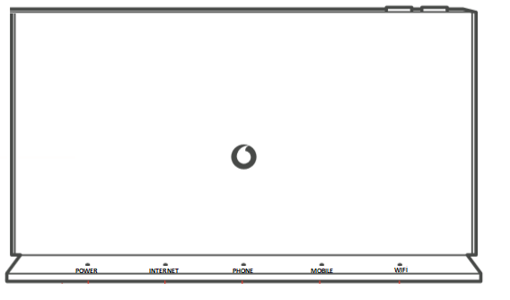
Figure 1: LEDs
Power LED | - On (White) - Power on.
Internet LED | - On (White) - connected to the Internet successfully.  - Blinking (White) - Broadband connection is active.  - Blinking fast (Red) - Connection error.
Phone LED | - On (White) - Broadband voice is working.  - On (Red) - Broadband voice error.  - Blinking slow (White) - Ongoing call.
Mobile LED | - On (White) - Connected via 3G or 4G.
Wi-Fi LED | - On (White) - Wi-Fi is on.  - Blinking slow (White) - WPS (device) pairing in progress.

Rear Panel
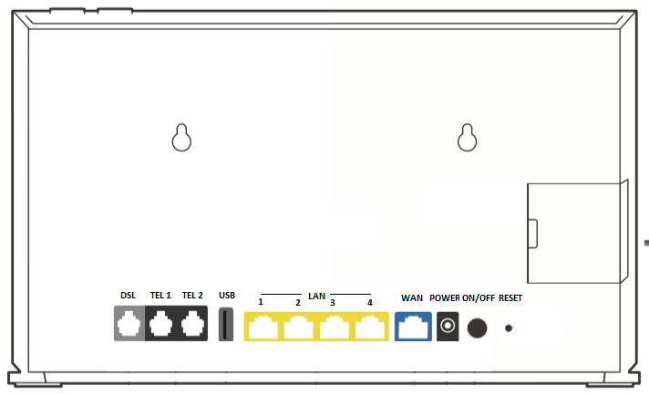
Figure 2: Rear Panel
DSL Port | Use the RJ-11 cable to connect DSLAM (Digital Subscriber Line Access Multiplexer)
TEL 1/2 Ports | Use the RJ11 cables to connect analog phones for VoIP service.
USB Port | The connector is USB host with support for mass storage device.
LAN Ports  (1~4) | Use standard LAN cables (RJ45 connectors) to connect your PCs to these ports.
WAN Port | Connect the DSL or Cable Modem here. If your modem came with a cable, use the supplied cable. Otherwise, use a standard LAN cable.
Power | Connect the supplied power adapter here.
ON/OFF | Press the switch to turn on/off the device.
Reset | This button has the following function:  - Reboot. When pressed less than 10 seconds, the device will reboot (restart).  - Clear All Data. Keep holding the button down for more than 10 seconds, it will clear ALL data and restore ALL settings to the factory default values.

Top Panel
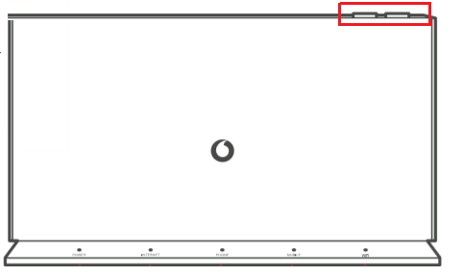
Figure 3: Top Panel

Wi-Fi Button | Press the button to turn on/off the Wi-Fi function.
WPS Button | - Press the button for more than five seconds to enable the WPS function.  - Wi-Fi function is disabled when press the button less than five seconds

Chapter 2
Installation
2
This Chapter covers the physical installation of the Vodafone Gigabox.

Requirements
- Network cables. Use standard 10/100/1000BaseT network (Ethernet) cables with RJ45 connectors.
- For Internet Access, an Internet Access account with an ISP, and a DSL connection.

Procedure
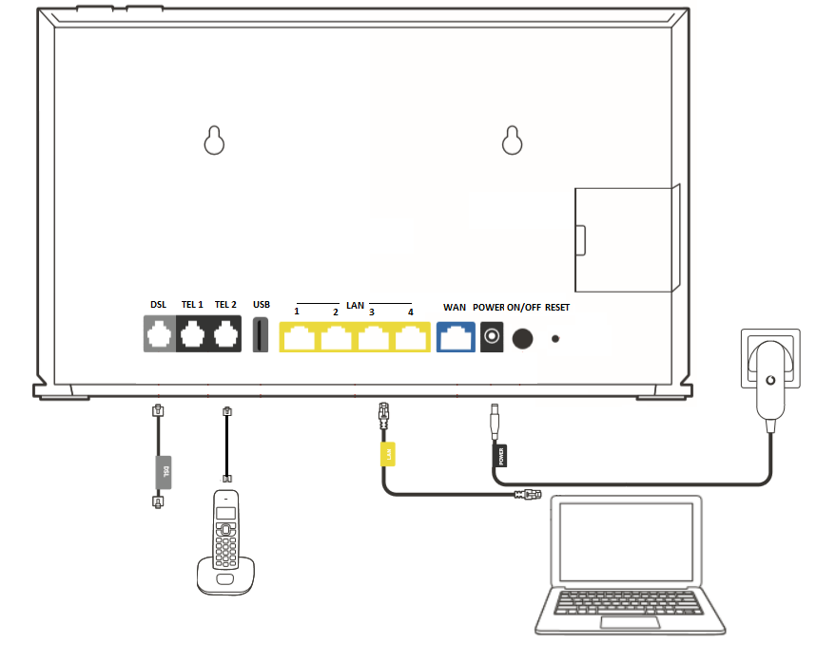
Figure 4: Installation Diagram
1. Choose an Installation Site
Select a suitable location for the installation of your Vodafone Gigabox.
2. Connect LAN Cables
Use a standard LAN cable to connect the device to LAN port of the PC
3. Connect DSL Cable
Connect the DSL port of the device to an active phone socket, via the provided DSL cable.
4. Connect Telephone
You can connect up to two analogue end devices (i.e. analogue phones) directly into TEL1 and TEL2 (FXS) ports of the device.
5. Power Up
Connect the supplied power adapter to the device and a convenient power outlet, and turn on the switch. Use only the power adapter provided. Using a different one may cause hardware damage.
6. Check the LEDs
- The Power LED should be ON.
For more information, refer to LEDs in Chapter 1.

How to establish a WAN (Wide Area Network) Connection
A wide area network (WAN) is a computer network that extends over a large geographical distance. A WAN port is the portal by which information can be passed back and forth between the LAN and the WAN.
- Use an RJ11 cable to connect the telephone plug in your household to the DSL plug on your gateway or use an Ethernet cable to connect the WAN port of your gateway to a cable modem/DSL modem.
- Plug the gateway's power cord in, and then press the switch to turn it on. Your gateway will start to boot. The LED ‘Power’ will blink until the preparation is finished. Check the modem and gateway lights to confirm they have power, and connect to the network and your computer. The Internet LED (White) should be on automatically.
- Connect one of the LAN ports of your gateway to the LAN interface of your personal computer/laptop if you want to see more info.
- Start your WEB browser on your personal computer/laptop, enter "HTTP://192.168.1.1" in the address box and login name/password (Please refer "Chapter 3 Preparation" for instructions). The Internet LED (White) should be on.
- Click "Status & Support" tab you can see "System", "Internet", "LAN Network", "Wi-Fi" and "MBB Dongle" information.

How to establish a Wi-Fi Connection
In a wireless home network, the connection between the devices is established by radio waves. The devices have to be equipped with a WLAN adapter in accordance with standard IEEE 802.11ac, 802.11b, IEEE 802.11g or IEEE 802.11n.

Requirements for configuration.
- You have installed your device and checked the network configuration of your PC/Laptop/Mac.
- The network capable device has established a connection with the device (through WAN or LAN).
- Open the web browser in the PC and type the default IP address of the gateway. Default IP is 192.168.1.1. Enter the user name and password (the default name and password are on the bottom of the device) to access Vodafone Gigabox GUI.
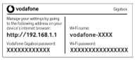
- Go to Wi-Fi - General to configure the Wi-Fi settings.
- Enter the Wi-Fi name (SSID) and the other related settings. (Please refer to "Wi-Fi" section)
- Go to Wi-Fi - WPS to configure the settings, which can be used to automatically configure wireless security for your wireless network(s).
Now you can connect to the network through the gateway.

Connect telephone
You can connect up to two analogue end devices (i.e. fax device, analogue phones) to your gateway.
1. Connect your analogue telephone, fax machine or answering machine to the TEL1 or TEL2 of your gateway.
2. Go to Phone - Call Settings to configure the related settings. Details on configuring
Telephony functions are presented in the later chapter.

Chapter 3
Setup & Status Basic Mode
3
This Chapter provides Setup details of the Vodafone Gigabox.

Overview
This chapter describes the setup procedure for:
- Internet Access
- LAN configuration
Other configuration may also be required, depending on which features and functions of the Vodafone Gigabox you wish to use.

Configuration Program
The Vodafone Gigabox contains an HTTP server. This enables you to connect to it, and configure it, using your Web Browser. Your Browser must support JavaScript.
The configuration program has been tested on the following browsers:
- Firefox
- Chrome
- Internet Explorer 10 or later

Preparation
Before attempting to configure the Vodafone Gigabox, please ensure that:
- Your PC can establish a physical connection to the Vodafone Gigabox. The PC and the Vodafone Gigabox must be directly connected (using the Hub ports on the Vodafone Gigabox) or on the same LAN segment.
- The Vodafone Gigabox must be installed and powered ON.
- If the Vodafone Gigabox's default IP Address (192.168.1.1) is already used by another device, the other device must be turned OFF until the Vodafone Gigabox is allocated a new IP Address during configuration.

Using your Web Browser
To establish a connection from your PC to the Vodafone Gigabox:
- After installing the Vodafone Gigabox in your LAN, start your PC. If your PC is already running, restart it.
- Start your WEB browser.
- In the Address box, enter "HTTP://" and the IP Address of the Vodafone Gigabox, as in this example, which uses the Vodafone Gigabox's default IP Address:
HTTP:// 192.168.1.1
- Enter the login name and password.
- If using the default values, enter the data on the product label for the name and password.

Overview Screen
After login, you will see the Overview screen. When you connect in future, you will see this screen when you connect. An example screen is shown below.
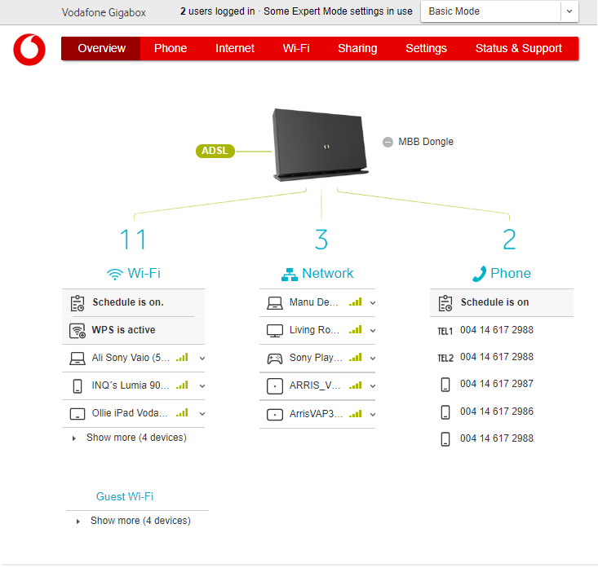
Figure 5: Overview Screen

Main Menu
The main menu also contains two (2) functions:
- Mode - Choose Basic Mode from the list.
- Logout - When finished, you should click this button to logout.

Navigation & Data Input
- Use the menu bar on the left of the screen, and the "Back" button on your Browser, for navigation.
- Changing to another screen without clicking "Apply" does NOT save any changes you may have made. You must "Save" before changing screens or your data will be ignored.

Phone - Call Log
Use the Call Log link on the Phone menu to reach the screen. An example screen is shown below.
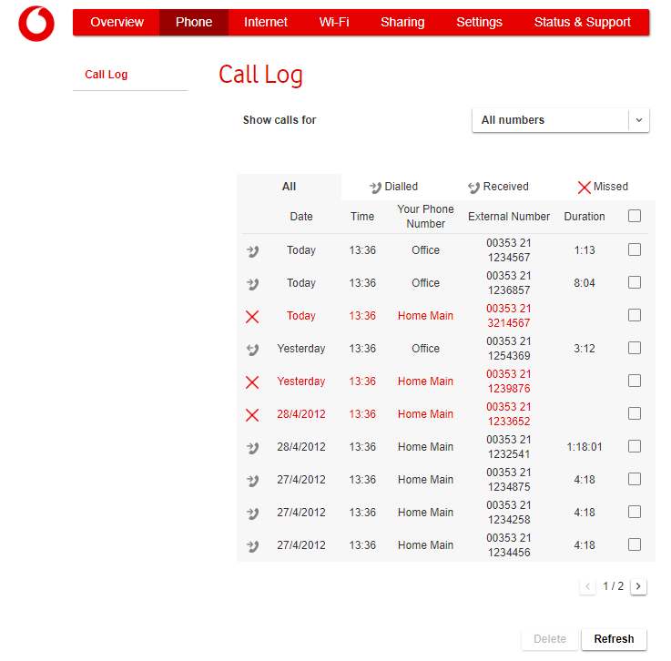
Figure 6: Call Log Screen

Data - Call Log Screen
Call Log
Call Log | This table displays all the details of dialed/received/missed calls.
Delete | Enable the box of the selected call and click the button to remove from the list.
Refresh | Click this button to refresh the data in the screen.

Internet - Firewall
This screen allows you to configure the settings of the firewall.
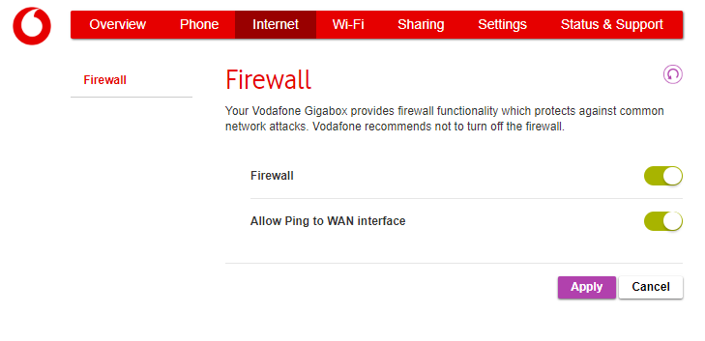
Figure 7: Firewall Screen

Data - Firewall Screen
Firewall
Firewall | This function is used to protect the network attacks. It is suggested to keep the firewall function enabled
Allow Ping to WAN Interface | Default is enabled.

Wi-Fi - General
Use the General link on the Wi-Fi menu to reach the screen. An example screen is shown below.
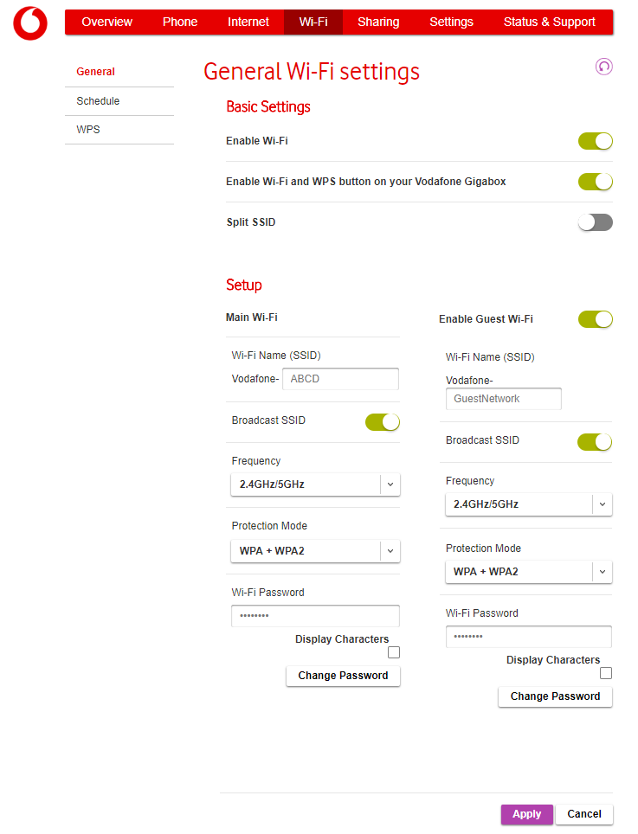
Figure 8: General Screen

Data - General Screen
Basic Settings
Enable Wi-Fi | If you turn it off, the Wi-Fi will be disabled, so the device will not provide or broadcast any wireless LAN services.
Enable Wi-Fi and WPS button on your  Vodafone  Gigabox | The Wi-Fi function and the WPS button of the device are available to use if the checkbox is enabled.
Split SSID | The default is disabled.
2.4 GHz/5 GHz
Guest Wi-Fi | If you turn it on, the guest Wi-Fi will be enabled.
Wi-Fi Name (SSID) | The SSID is the equivalent to the wireless network's name and it is preset to a prefix and unique number. You can either leave it as is, or change it by entering a freeform name of up to 32 characters, for example "ED's Wireless LAN".  Note: The value is case-sensitive.
Broadcast SSID | It is possible to make your wireless network nearly invisible. By turning off the broadcast of the SSID, your network will not appear in a site survey.
Frequency | Select the desired frequency from the list.
Protection Mode | Select the desired option, and then enter the settings for the selected method:  - off - No security is used. Anyone using the correct SSID can connect to your network.  - WPA2 - WPA2 is more secure and should be used if possible.  - WPA+WPA2 - Like WEP, data is encrypted before transmission. WPA2 is the version of WPA which does NOT require a Radius Server on your LAN.  - WEP - The 802.11b standard. Data is encrypted before transmission, but the encryption system is not very strong.
Wi-Fi Password | It displays the key that is currently used.  - Click Change Password button if you want to modify. Enter the key value you wish to use. Other stations must have the same key values.  - Keys must be entered in Hex. Hex characters are the digits (0 ~ 9) and the letters A ~ F.

Wi-Fi - Schedule
Use the Schedule link on the Wi-Fi menu to reach the screen. An example screen is shown below.
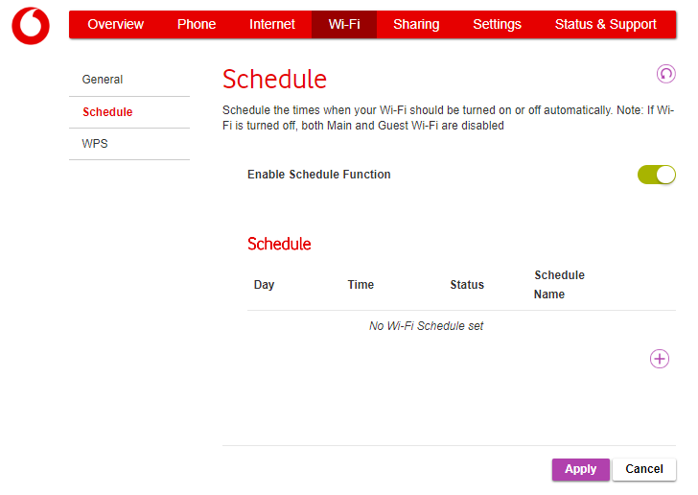
Figure 9: Schedule Screen

Data - Schedule Screen
Schedule
Enable Schedule  Function | If turn this feature on, you can set the schedule of Wi-Fi function to be enabled.
Schedule | It will list the existing schedules here.
Add Button | Click this button to add a new Wi-Fi schedule.
Edit Button | Use this button to modify the Wi-Fi schedule.
Delete Button | Click this button to remove the Wi-Fi schedule.

Wi-Fi - WPS
Wi-Fi Protected Setup is a feature that makes it easy to set up your wireless network. If you have devices that support Wi-Fi Protected Setup, then use the following instructions. If you have client devices, such as a wireless adapter, that supports Wi-Fi Protected Setup, then you can use Wi-Fi Protected Setup to automatically configure wireless security for your wireless network(s).
NOTE: Wi-Fi Protected Setup configures one client device at a time.
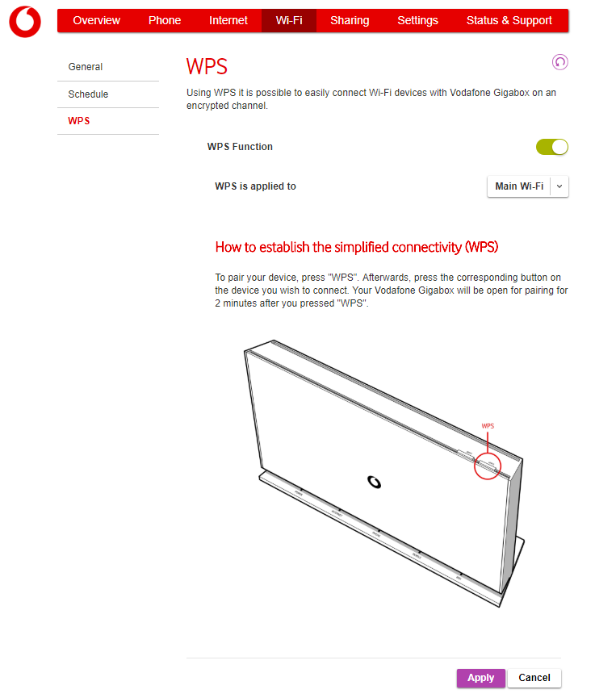
Figure 10: WPS Screen

Data - WPS Screen
WPS
WPS Function | If enabled, the WPS function will be used.
WPS is applied to | Choose the option from the list.
WPS-PBC | - Press the WPS button on the Gigabox.  - Press the Wi-Fi Protected Setup button on the client device in 2 minutes. (If Wi-Fi Protected Setup is an on-screen option, then  select it.)

Sharing - General Setting
Use the General Setting link on the Sharing menu to reach the screen. An example screen is shown below.
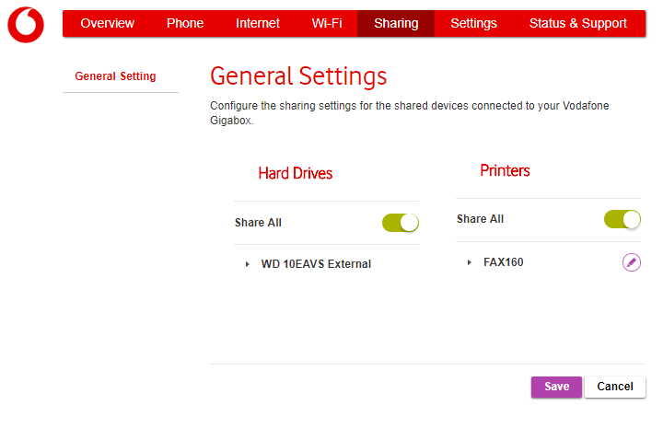
Figure 11: General Setting Screen

Data - General Setting Screen
General Setting
Hard Drives | If enabled, the connected hard drives are available to be shared:
Printers | The connected printers can be shared if this function is turned on.
Edit | Click this button to modify the name of the device

Settings - Password
Use the Password link on the Settings menu to reach the screen. An example screen is shown below.
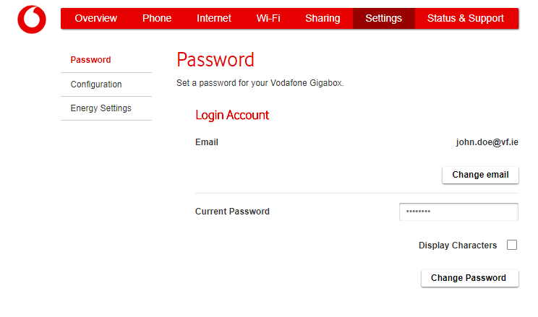
Figure 12: Password Screen

Data - Password Screen
Password
Email | It displays the current email address.
Change email | Click this button to change the email address, and then click Save button.
Change  Password Button | Click this button to change password of the selected user.  - Current Password: Enter the old password.  - New Password: Enter the new password.  - Re-enter Password: Enter the new password again.  - Password Strength: It displays the strength of the password.

Settings - Configuration
This feature allows you to download the current settings from the device, and save them to a file on your PC or other devices.
You can restore a previously-downloaded configuration file to the device, by uploading it to the device.
This screen also allows you to set the device back to its factory default configuration. Any existing settings will be deleted.
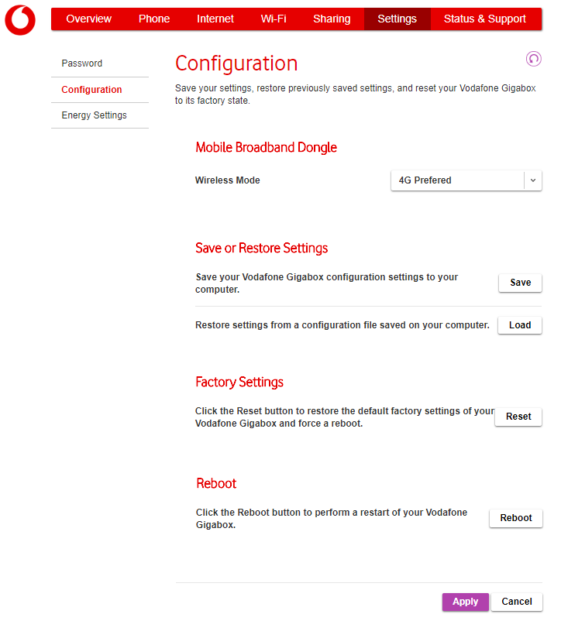
Figure 13: Configuration Screen

Data - Configuration Screen
Mobile Broadband Dongle
Wireless Mode | There are four options of the list:  - 4G Preferred  - 3G Preferred  - 2G Preferred  - Auto
Save or Restore Settings
Save | Use this to download a copy of the current user configuration, and store the file on your PC.
Load | This allows you to restore a previously-saved user configuration file from the PC.
Factory Settings
Reset to Factory Settings | Clicking the Reset button will reset the device to its factory default settings.  WARNING!  This will delete ALL of the existing settings.
Reboot
Reboot | Clicking the Reboot button will restart the device.

Settings - Energy Settings
Use the Energy Settings link on the Settings menu to reach the screen. An example screen is shown below.
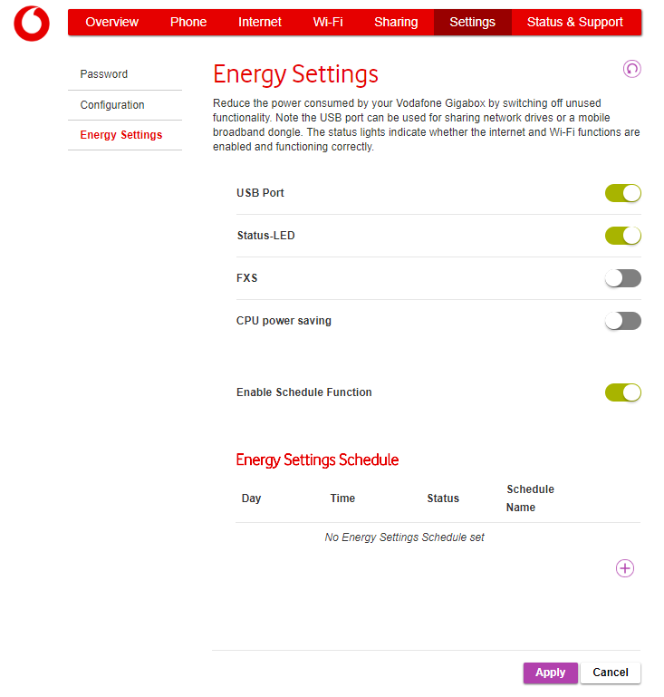
Figure 14: Energy Settings Screen

Data - Energy Settings Screen
Energy Settings
USB Port | Turn off the USB function if you want to save more power.
Status LED | You can save more power if LED function is disabled.
FXS | Turn off the FXS function to reduce power consumption.
CPU Power Saving | Default is disabled.
Enable Schedule Function | You can set the schedule of the energy settings if needed.
Energy Settings Schedule | It will list the existing energy schedules here.
Add Button | Click this button to add a new energy schedule.
Edit Button | Use this button to modify the energy schedule.
Delete Button | Click this button to remove the energy schedule.

Status & Support - General Information
Use the Status link on the Status & Support menu to reach the screen. An example screen is shown below.
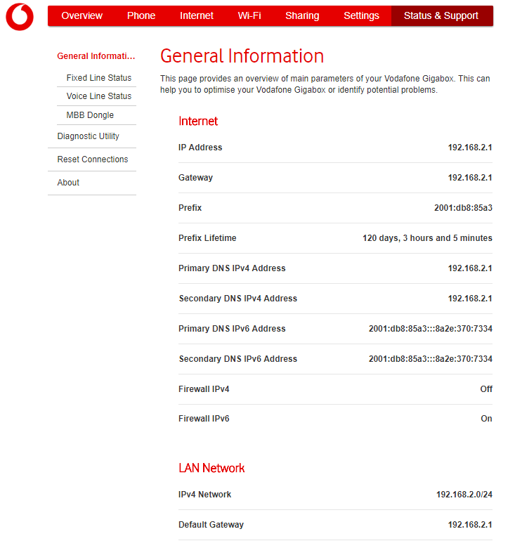
Figure 15: Status Screen

Data - Status Screen
Internet
IP Address | The IP address of the device.
Gateway | The gateway of the IP address above.
Primary DNS IP Address | The IP address of the primary DNS server.
Prefix | The prefix of the above IP.
Prefix Lifetime | The lifetime of the prefix.
Primary DNS IPv4/v6 Address | The IP address of the primary DNS server.
Secondary DNS IPv4/v6 Address | The IP address of the secondary DNS server.
Firewall IPv4/IPv6 | This shows the status of the firewall function.
WAN IP Address | The IP address of the WAN server.
LAN Network
IPv4 Network | The Network Mask of the IPv4 address.
Default Gateway | The gateway of the IP address.
Subnet Address | This displays the subnet address of the device.
MAC Address | This shows the MAC address of the device.
DHCP Server | This shows the status of the DHCP Server function. The value will be "On" or "Off".
LAN Port (1-4) | The status and of the specific LAN port.
Wi-Fi (Main/Guest)
Status | This shows the status of the Wi-Fi function. The value will be "On" or "Off".
Name | It displays the name of the SSID.
MAC Address | The MAC (physical) address of the AP.
Security | This indicates the current security in use.
IP Network | This shows the IP address of the network.
Subnet Address | This displays the subnet address of the guest Wi-Fi.
DHCP Server | This shows the status of the DHCP Server function. The value will be "On" or "Off".
MBB Dongle
Online since | It displays the online time of the dongle.
IP Address | The IP address of the dongle.
System | The IP address of the system.
Mode | The current mode of the dongle.
System
Serial Number | This displays the serial number of the device.
Firmware Version | The current version of the firmware installed in the device.
Boot Loader Version | The version of the boot loader is displayed.
Hardware Type & Version | The current version and type of the hardware.
Uptime since last reboot | The time spent since the last device reboot.
CPU Usage | The usage of the CPU.
Memory Usage | The usage of the memory.

Fixed Line Status
This screen contains the status of DSL and Fibre.
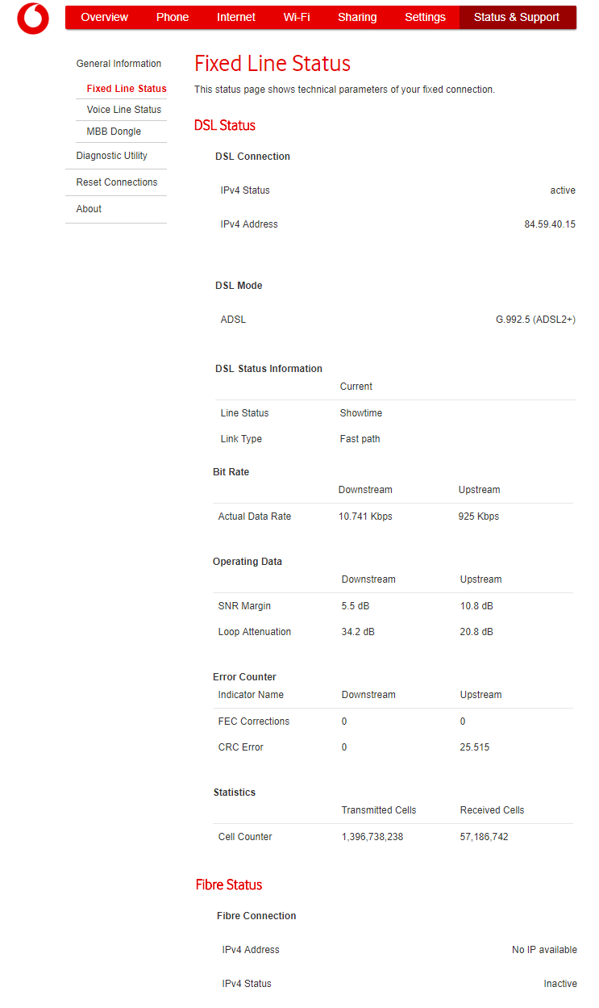
Figure 16: Fixed Line Status Screen

Data - Fixed Line Status Screen
DSL
DSL Mode | This displays the mode of the ADSL.
DSL Status  Information | The current DSL status.
Bit Rate | The downstream/upstream of the bit rate.
Operation Data | The downstream/upstream of the operation.
Error Counter | The downstream/upstream of the error counter.
Statistics | It displays the transmitted cells/received cells of cell counter.
Fibre
IPv4 Address | The address of the IPv4
IPv4 Status | The current status of IPv4.

Voice Line Status
It displays the current voice line status.
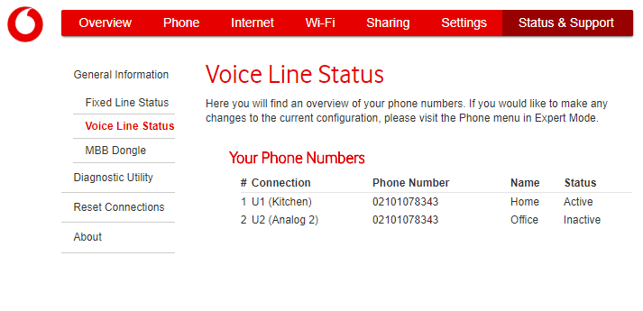
Figure 17: Voice Line Status Screen

Data - Voice Line Status Screen
Voice LineStatus
Your Phone Number | This displays the phone number, name and status of the  connection.

MBB Dongle Status
This screen contains the status of the dongle.
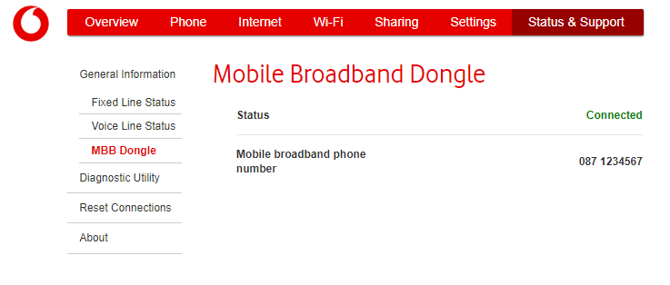
Figure 18: Mobile Broadband Dongle Status Screen

Data - Mobile Broadband Dongle Status Screen
Mobile Broadband Dongle
Status | The status of the dongle.
Mobile broadband phone number | It shows the number of the mobile.

Status & Support - Diagnostic Utility
Use the Diagnostic Utility link on the Status & Support menu to reach the screen. An example screen is shown below.
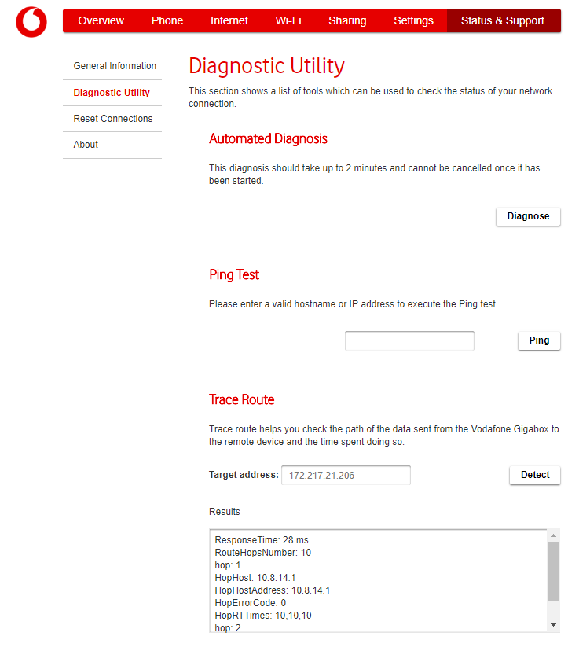
Figure 19: Diagnostic Utility Screen

Data - Diagnostic Utility Screen
Automated Diagnosis
Diagnose | Click this button to test the network connection status. A new screen will appear and display the test results.
Ping Test
Ping | Enter a valid hostname or IP address and click this button to test the connection.
Trace Route
Detect | This function can help you to check the path of the data sent from the Vodafone Gigabox to the remote device. Click this button after entering the data in the field. The route details is displays in the following table.

Status & Support - Reset Connections
Use the Reset Connections link on the Status & Support menu to reach the screen. An example screen is shown below.
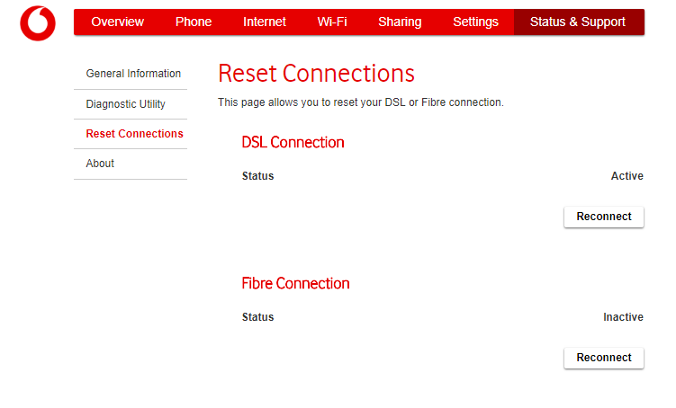
Figure 20: Reset Connections Screen

Data - Reset Connections Screen
Reset
DSL Connection | Use the Reconnect button to restart the DSL connection.
Fibre connection | Use the Reconnect button to restart the fibre connection.

Status & Support - About
Use the About link on the Status & Support menu to reach the screen. An example screen is shown below. This screen displays the information of the software and license.
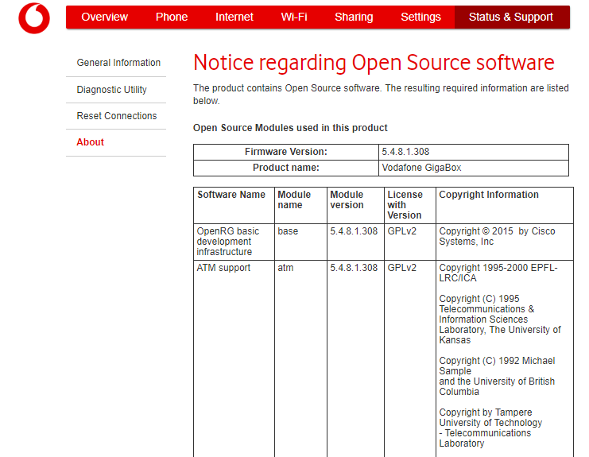
Figure 21: About Screen

Chapter 5
Troubleshooting
5
This Chapter details the status screens.

Overview
This chapter covers some common problems that may be encountered while using this device and some possible solutions to them. If you follow the suggested steps and it still does not function properly, contact your dealer for further advice.

Problems
Problem 1: | The device cannot find the WAP (Wireless Access Point).
Solution 1: | Try the following methods:  - Check if you have enabled the Wi-Fi schedule in the Wi-Fi GUI.  - Check if the Broadcast SSID is enabled.  - Check the Wi-Fi channel, or change it to another channel.  - Check if the Wi-Fi driver has been installed correctly in the PC.  - Locate the WAP, PC or notebook to a better place.  - Check if the wireless MAC filter has been enabled or not.
Problem 2 | The Internet connection cannot be established.
Solution 2 | Try the following methods:  - Check if the PC gets the correct IP address.  - Ping the IP to see if it is working.  - Check the DNS server is working properly or not. Try to ping a domain, such as “google.com” and an IP address e.g.: “8.8.8.8”.  - Check the WAN status. The Internet LED should be ON, and route should be installed properly

Appendix A
Specifications
A

Vodafone Gigabox
Model | Vodafone Gigabox
Dimensions | 275mm(W) * 32mm(D) * 165mm(H)
LAN Port | 4 * 10/100/1000BaseT (RJ45) LAN Ports
WAN Port | 1 * 10/100/1000BaseT WAN Port
USB | 1 * USB 2.0 port
Wireless Interface | IEEE 802.11ac/802.11n/802.11b/802.11g compatible
Buttons | 1* Power On/Off Button  1* WPS Button  1* Wi-Fi On/Off Button
Switch | 1* Reset
LEDs | 5
Power Adapter | 12V 2.5A

Regulatory Approvals

FCC Statement
This equipment has been tested and found to comply with the limits for a Class B digital device, pursuant to Part 15 of the FCC Rules. These limits are designed to provide reasonable protection against harmful interference in a residential installation.
This equipment generates, uses and can radiate radio frequency energy and, if not installed and used in accordance with the instructions, may cause harmful interference to radio communications. However, there is no guarantee that interference will not occur in a particular installation. If this equipment does cause harmful interference to radio or television reception, which can be determined by turning the equipment off and on, the user is encouraged to try to correct the interference by one of the following measures:
- Reorient or relocate the receiving antenna.
- Increase the separation between the equipment and receiver.
- Connect the equipment into an outlet on a circuit different from that to which the receiver is connected.
- Consult the dealer or an experienced radio/TV technician for help.
To assure continued compliance, any changes or modifications not expressly approved by the party responsible for compliance could void the user's authority to operate this equipment. (Example - use only shielded interface cables when connecting to computer or peripheral devices).
FCC Radiation Exposure Statement
This equipment complies with FCC RF radiation exposure limits set forth for an uncontrolled environment. This equipment should be installed and operated with a minimum distance of 20 centimeters between the radiator and your body.
This device complies with Part 15 of the FCC Rules. Operation is subject to the following two conditions:
(1) This device may not cause harmful interference, and
(2) This device must accept any interference received, including interference that may cause undesired operation.
This transmitter must not be co-located or operating in conjunction with any other antenna or transmitter.

